DNA: Cracking the Code
A gene is like a long sentence which gives instructions on how to make part of a person.
Each sentence consists of lots of three letter ‘words’. These words are written in a code, using only the letters A, T, C and G (abbreviations for the bases Adenine, Thymine, Cytosine and Guanine).
Each word is called a codon, and codes for a piece of protein called an amino acid.
These amino acid join together in a chain to form a protein, which determines something about you – for example your hair colour.
The Genetic Code for Amino Acids
2nd letter→  1st letter | T |  | C |  | A |  | G
T | TTT | Phe | TCT | Ser | TAT | Tyr | TGT | Cys
T | TTC | Phe | TCC | Ser | TAC | Tyr | TGC | Cys
T | TTA | Leu | TCA | Ser | TAA | Stop | TGA | Stop
T | TTG | Leu | TCG | Ser | TAG | Stop | TGG | Trp
C | CTT | Leu | CCT | Pro | CAT | His | CGT | Arg
C | CTC | Leu | CCC | Pro | CAC | His | CGC | Arg
C | CTA | Leu | CCA | Pro | CAA | Gln | CGA | Arg
C | CTG | Leu | CCG | Pro | CAG | Gln | CGG | Arg
A | ATT | Ile | ACT | Thr | AAT | Asn | AGT | Ser
A | ATC | Ile | ACC | Thr | AAC | Asn | AGC | Ser
A | ATA | Ile | ACA | Thr | AAA | Lys | AGA | Arg
A | ATG | Met | ACG | Thr | AAG | Lys | AGG | Arg
G | GTT | Val | GCT | Ala | GAT | Asp | GGT | Gly
G | GTC | Val | GCC | Ala | GAC | Asp | GGC | Gly
G | GTA | Val | GCA | Ala | GAA | Glu | GGA | Gly
G | GTG | Val | GCG | Ala | GAG | Glu | GGG | Gly
TThe three letter abbreviations (Phe, Leu, etc) are the names of the amino acids.

A protein is made up of a chain of amino acids
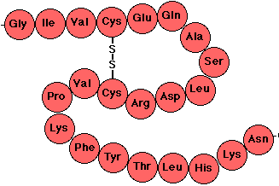
Here are the proteins that determine hair colour:
Met-Ser-Thr-Gln-Phe = Red hair
Met- Ser-Thr-His-Leu = Blonde hair
Met-Pro-Thr-His-Phe = Black hair
Met-Pro-Thr-Gln-Leu = Brown hair

Using the decoder above, find out what colour hair each of these boys will have, according to their hair colour gene. (Hint: separate each codon with a dash eg. TAG/GAT/CCA…)
 |  | 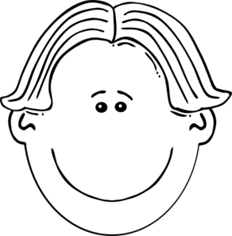 | 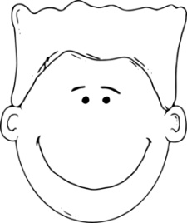
DNA | ATGTCAACTCATCTCTAA | ATGCCAACTCATTTCTAG | ATGTCAACTCAATTCTAG
Protein
Hair colour

